Ideation Phase
Brainstorm & Idea Prioritization Template

Date | 08-12-2025
Team ID
Project Name | Book Store
Maximum Marks | 4 Marks

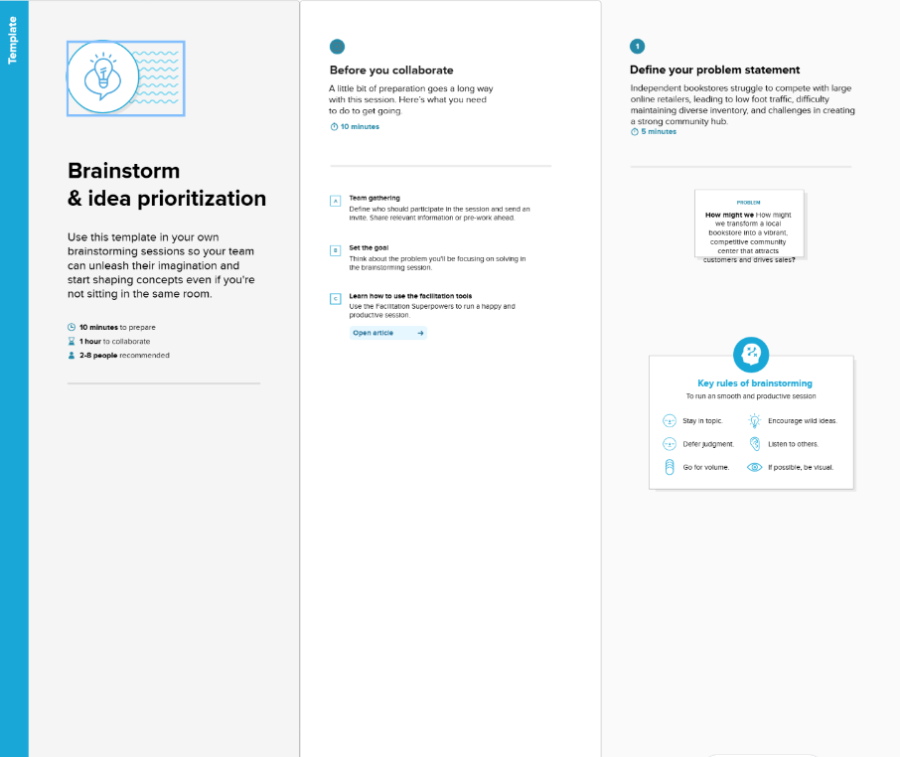

Step-2: Brainstorm, Idea Listing and Grouping
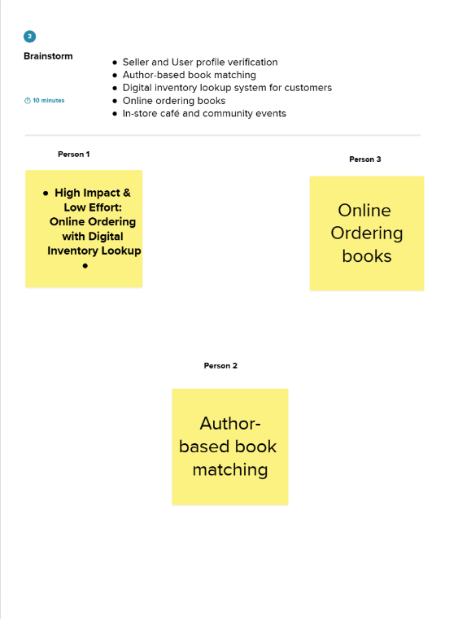
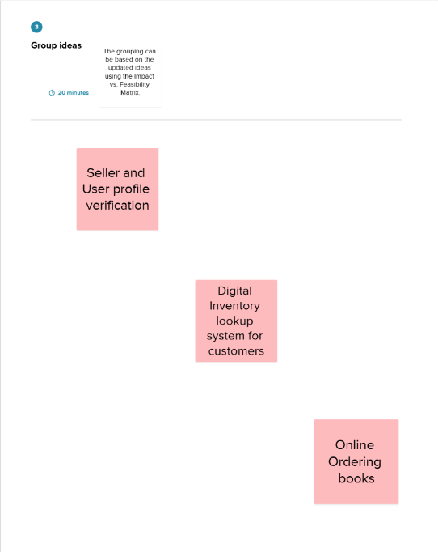

Step-3: Idea Prioritization
